Agile Dungeon Trekking

Using TDD to build the landing page, register user, login, logout, and reset password.

The initial Django project was created using the PyCharm template.

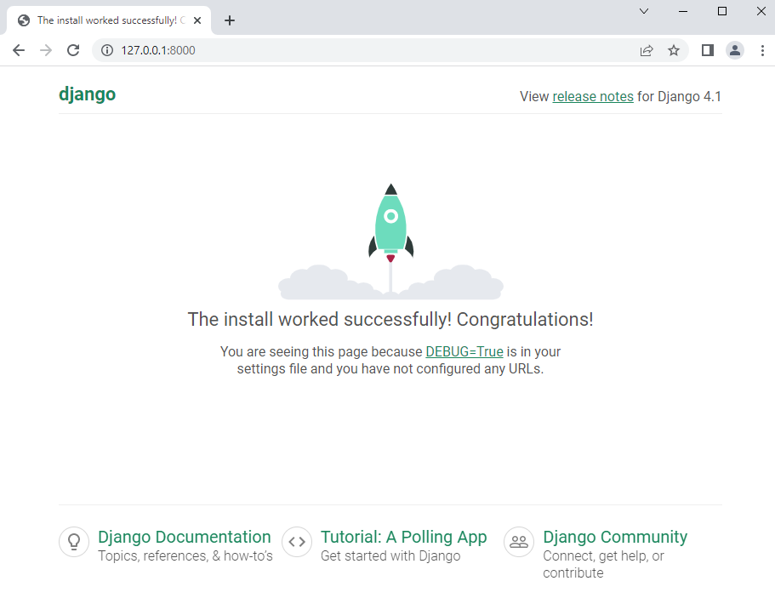

Created test for landing page

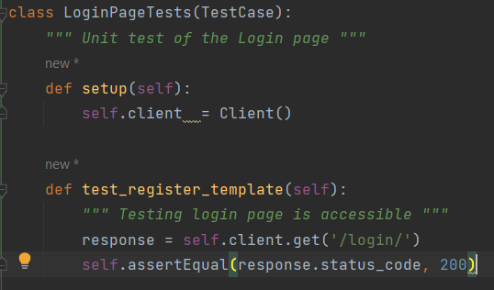

Ran the test and it failed.

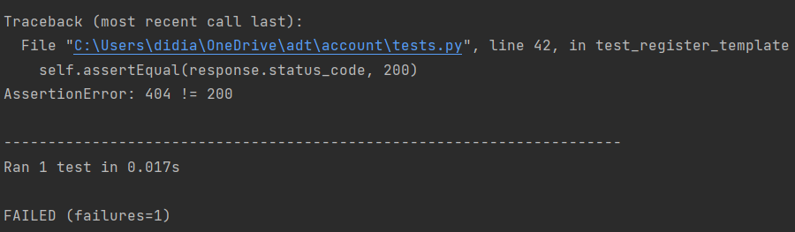

The error indicates that the login page is not found as indicated by the http 404 error.

The default project has debug turned on, so this is why we can see an initial page but it is not the page we want. The way to resolve this is to create our login page.

For this project, we will use the Django provided authentication modules, which includes the login page.

Added the necessary steps for the website to route to our login view.

Now we can re-run the test.

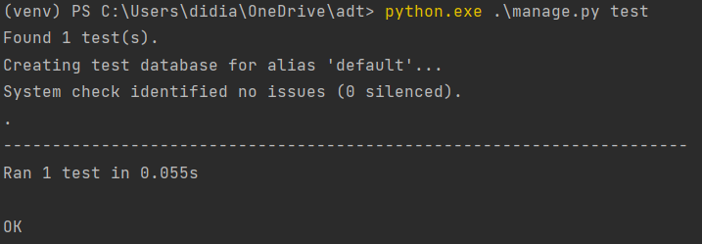

Test now passes.

The next item is to work on the log in process. There are two components. First is the page that accepts a username and password with the option to create an account. If the user logins successfully, the main page is shown. If the user clicks on the registration link, then the registration page is shown.

The account app is created and test for the login page and registration page are added.

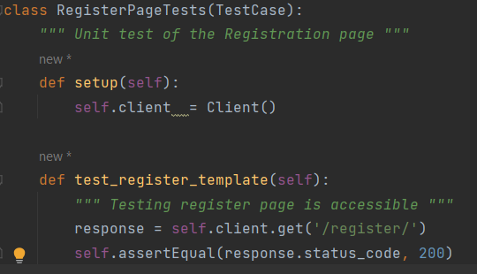

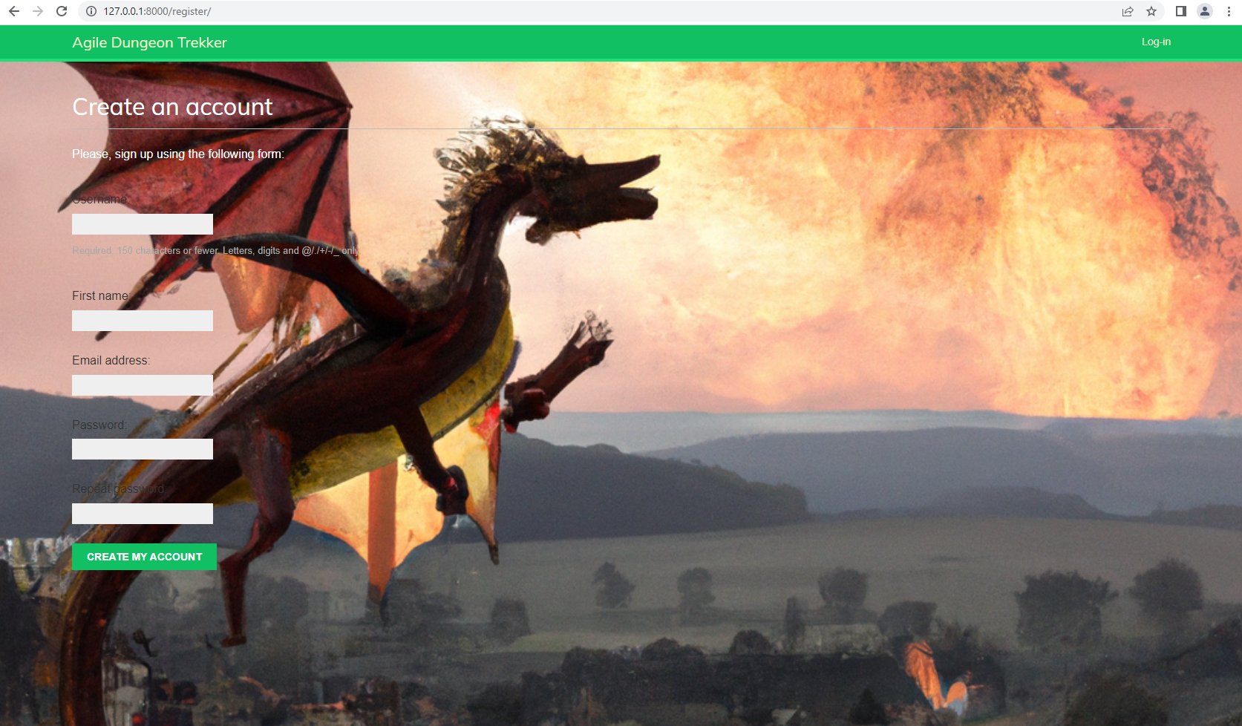

Added business rules for our User model.

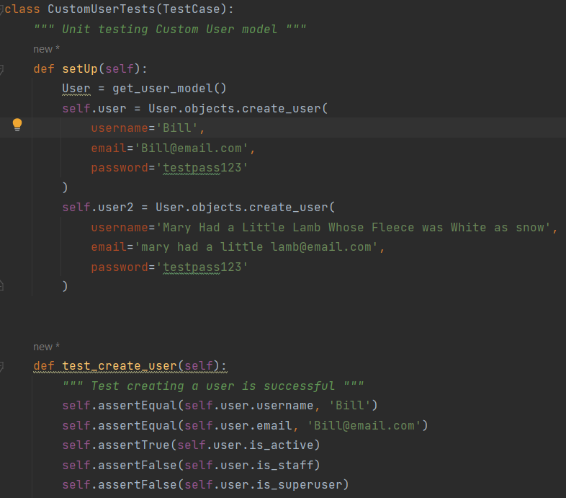

The story states rules for username length, email length and validation, password length

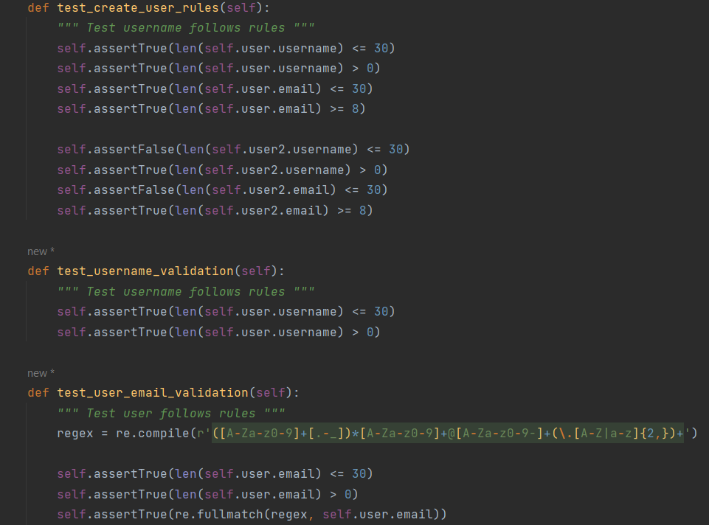

This first pass our tests test the rules on a known user. Eventually we want the tests to get values form the web page form.

Other validation rules added to check invalid username entered and invalid password entered.

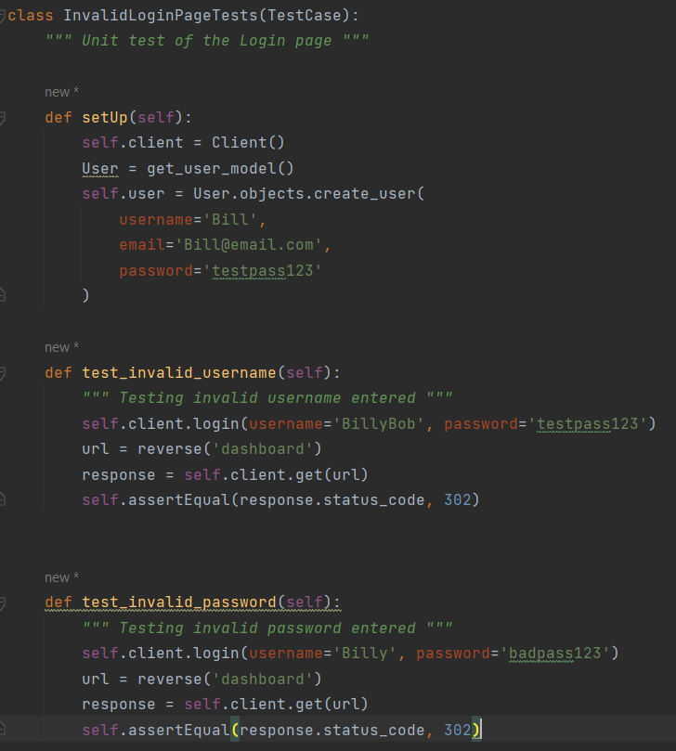

Tests are passing

